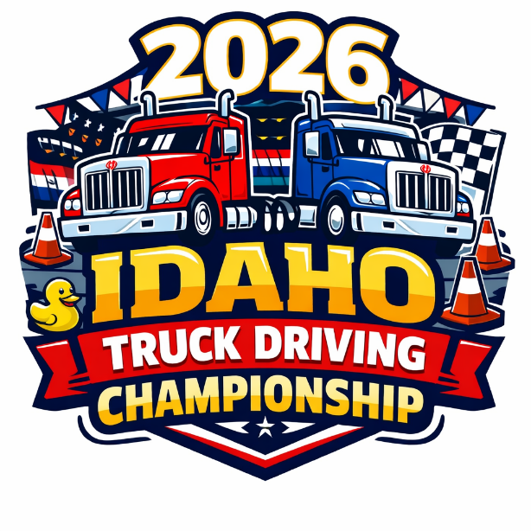

2026 Idaho
TDC Participation Guide

May 2nd, 2026
Idaho State Police Training Facility (POST)
700 S. Stratford, Meridian, ID 83642

RULES, INSTRUCTIONS, & INFORMATION FOR
THE IDAHO TRUCK DRIVING CHAMPIONSHIPS



SCHEDULE OF EVENTS

Friday May 1st: 8:00am – 3:00pm Set Up Only!
Equipment Drop Off & Course and Event Set Up
- Including tailgate tents.
Saturday May 2nd:
6:30am Early Volunteer Check In
7:00am Driver Check In
7:00am Volunteer Check In
7:30am Written Test – All Drivers
8:30am Welcome & Introduction
8:45am Course Walk Thru
9:00am Wheels Roll!!
3:00pm Awards Ceremony (estimated)
3:45pm Event Clean Up

All drivers MUST be present for the Written Test & Welcome and Introduction starting at 7:30 AM. Drivers who are not present will not be eligible to compete.

Drivers are encouraged to spend time with their families, except when they are called to compete in their respective class events.
Call to Tent: Prior to their course competition, drivers will be called to the designated driver tent by class group (i.e. 3-axle, twins).
Sequestration: Once called, drivers must remain in the driver tent until they complete their course run. The duration of this time is dependent on the number of competitors in their class. Once drivers complete their course, they may return to their company area.
Observation of Other Classes: While in the tent drivers are not permitted to observe their class compete on the course.
Attendance Requirement: Announcements will be made to call classes have been called to the driver tent. Our announcer will make these announcements from the stage area by the P.A. system. Make sure someone from your company can hear the announcements. Drivers can also keep aware of the class that is on the course and use the run order to know which class is next in line. Ultimately, drivers are responsible for staying informed. There are no fixed scheduled times; participation is based on the completion of each group's activities. If drivers are not available when their turn arrives, they may face disqualification from the competition.
Pre-Trip Event: Similarly, drivers must be present in the driver tent before their scheduled pre-trip Inspection. Drivers are not permitted to discuss the pre-trip inspection or the course with other drivers.

These rules are implemented to ensure the smooth operation of the competition, uphold fairness among all participants and to ensure an enjoyable experience for everyone involved.

DRIVER REGISTRATION
Companies are required to supply 1 Volunteer for every 3 drivers that they register to compete. Failure to supply volunteers will result in disqualification. Volunteers must be registered and must check in at the event. See below for Volunteers.
DRIVER REGISTRATION - DEADLINE: April 17, 2026
Step One: Register here
https://idtrucking.org/truck-driving-championship-registration/
Step Two: Email all registration forms and supporting documents to: office@idtrucking.org
The required supporting forms and documents must be submitted to ITA by the close of business on April 17, 2026. These forms and documents include the:
- ATA/ITA Driver Entry Form
- Current Motor Vehicle Record (MVR);
- CDL/driver’s license with proper endorsements
- Driver photo.
- Signed ITA waiver
COMPLETING DRIVER REGISTRATION:
All competitors must register using ITA's registration forms and submit additional forms and documents.
Current MVR – Must be pulled after February 20, 2026, and show that the driver's medical certificate is valid.
CDL copy – The driver must have the proper endorsements for the class entered.
If a driver's CDL or medical card expires by April 5, 2026, a new license or medical card must be provided by April 5, 2026, before they are eligible to compete.
Driver photo – Please send a clear head shot photo of the driver. License photo is fine – IF it is legible.
Step Three: Submit entry fees. Entry fee is $150 per driver. Entries after April 10 will be $175. No entries accepted after April 17. Drivers’ Company will be invoiced. Invoices can be paid by card online, or mail in check. Payments made by credit card will include a credit card fee of $4.64. To avoid this fee, please mail a check.
COMPETITOR ELIGIBILITY
COMPETING DRIVERS MUST:
- Be based or licensed in Idaho and in a driving position with their current employer since August 20, 2025. (some exemptions may apply)
- Perform a minimum of 1,200 hours annually as a professional truck driver.
- Have the proper license endorsement for the class of participation chosen.
- Have an accident-free driving record since August 20, 2025.
- Drivers with non-preventable crashes may be eligible to compete.
- Documentation must be submitted to the IDTDC Planning Committee by April 1, 2026, for all non-preventable crashes (including non-DOT recordable) for review.
- Have not been away from the regular driving duties beyond an aggregate of 30 calendar days since August 20, 2025.
Drivers compete in one of the following classes:
Step Van - Straight Truck - Flatbed - Sleeper - Twins - Tanker - 3 Axle - 4 Axle - 5 Axle
No class or driver changes will be accepted after April 17, 2026, including onsite.
Competitors should be in company identifying clothing and wear the
name badge provided during check-in.
Click Here to Star
Welcome & Instructions
All Drivers will report to the classroom for the written test at 7:30am. When they have completed the test, they will exit the classroom and wait for all drivers to complete the test. Then they will gather again in the classroom at 8:30 AM for the course instruction & slide show.

Skills Course
The skills course walk will commence at 8:45 AM. The course walk will be no more than 10 minutes, and drivers may not ask questions during the course walk. Drivers may not pace the course or measure the distance between problems or equipment. The use or possession of phones, smart watches, or pedometers is strictly prohibited and will result in disqualification. Discussion of the skills course or pre-trip details with other drivers is strictly prohibited until all drivers have completed the event activities.

WRITTEN TEST
Drivers do not need to bring anything for the written test and should not sit next to other competitors from their own company. Test is 40 questions, and drivers have one hour to complete it. Cell phones, smartwatches, or other prohibited devices must be left with a family member or in your car.
Purchase your study guide, “Facts for Drivers” https://www.atabusinesssolutions.com/Shopping/Landing.html

FACTS FOR DRIVERS
This is the study guide for the written exam and the driving competition. The 2026 TDC written test is based on information found in the 2026 Facts for Drivers. To order your book, please visit the ATA Business Solutions website. Search “2026 Facts for Drivers” on the shopping page.

PRE-TRIP INSPECTION
Drivers will not be provided with any tools. You must clearly announce any defects found, and what the defect is. You will not be told if you are correct. You will not be penalized for naming defects that are not part of the competition. Time Limits are based on vehicle Class.

CODE OF CONDUCT
Participation in all ITA hosted events is subject to the observance of the
ITA’s rules and procedures. The activities outlined below are strictly prohibited. Any participant, volunteer, or staff member who violates this Code is subject to removal from the 2026 ITA TDC activities and possible future ITA-hosted events.

- Cheating, use of cell phones, sharing of competition information for the purpose of gaining or giving an unfair advantage.
- SMOKING, possession or use of alcoholic beverages or illegal drugs within the POST Facility is strictly forbidden.
- Disrespectful behavior, including abusive language, rudeness, harassment (verbal, physical, or visual), violence, or conduct endangering the well-being of others, towards staff members, volunteers, or participants.
- Bullying or taking unfair advantage of any participant.
- Failing to cooperate with TDC leaders or ITA staff.
COMPANY INFORMATION
REGISTRATION:
Companies will be invoiced for their driver entries. Supervisor signatures are required on all registration forms, verifying the Driver is eligible to compete.
EVENT REFUND POLICY:
Cancellations prior to April 2, 2026 are eligible for a refund, less a 5% transaction fee.
Cancellations after April 17, 2026 are not eligible for a refund.
Cancellations can be transferred to another driver within the same company.
CLASS WINNERS
The Winning employer company must be a member of the Idaho Trucking Association (ITA) and provide the National Truck Driving Championship (NTDC) Entry Fee ($550) in order for the winning driver to be sent to nationals. Winning companies will be invoiced for the NTDC entry fee for submitted competitors.
All invoices must be paid by May 16, 2026, for NTDC entry.
Winners that are involved in a disqualifying event after the Idaho TDC, or are unable to go to NTDC will surrender their spot to the second place winner.
TAILGATE SET UP
Companies may request a location for a tailgate set up. Spaces will be 12x12, unless a larger space is requested. (20x20)

The ITA will not provide tents, tables or chairs. You may bring your own, or hire a local event rental vendor. You may want to contact Idaho Tent & Events, for your needs. www.idahotents.com 208-559-2771

To reserve a space, please contact the ITA: office@idtrucking.org
or call 208-342-3521

Companies are encouraged to bring food or entertainment for driver families. Drivers will be provided a lunch from the food truck.

Tailgate Rules:
  - Please keep pets at home.
  - Do not stake tents on the grass.
  - No smoking anywhere on ISP property
  - Keep children in your sight.
  - Please keep distractions away from the course (i.e. skateboards, balls etc.
  - No littering. Please respect ISP rules so we can continue to use their facility.
  - Do not enter the course, unless directed to do so, and only if wearing a safety vest.

VOLUNTEERS
VOLUNTEER REGISTRATION
The TDC is very volunteer intensive. Please invite coworkers, friends, and family to volunteer. There are plenty of jobs available for everyone, including teenagers. No experience is necessary!
Volunteering is required for all companies with 3 or more participants.
Click here to sign-up to Volunteer
https://idtrucking.org/tdc-volunteer-sign-up/

Please use the Volunteer Sign up! We may need to email you instructions or information prior to the event. If we do not have enough Volunteers registered, we may need to adjust the Event Schedule. If you need to cancel after signing up, email the ITA to let us know.
Please check in upon arrival. Wear the name tag provided. Volunteer supervisors will meet at the beginning of the day and will be responsible for coordinating volunteers in their area.
- Safety First! Be alert around all vehicles and equipment.
- All Volunteers are asked to follow the Code of Conduct as written above.
- Please do not enter the course without a safety vest.
- If you need to take a break, please alert a supervisor so we can cover your position.
- You may want to bring water, and weather appropriate clothing

SPECTATORS
Families are Welcome!!
We're excited to host an enjoyable and family-friendly event. While the atmosphere will be family-oriented, the primary focus will be on the competition, as we aim to identify the winners who will represent Idaho at the national level. It is our responsibility to maintain fair competition.

Families can enjoy the event from their designated company viewing areas. After competing, drivers can promptly reunite with their families. We aim to host an efficient and enjoyable event for all.

Amenities
Parking is available in front of the POST building, and around the POST facility.
Please do not park in the Course area, or the equipment staging area.
Toilets are located near the course entry gate.
A Food truck is available for your convenience.
Bring your own seating for comfort.

Rules
We want to keep the competition family friendly. Please follow these rules:
- For everyone’s safety, please do not enter the course. Remain behind all barricades.
- Children should not ride skateboards, throw balls, or do anything around the course that may compromise their safety or distract competitors.
- Please no pets.
- Smoking and alcohol are not allowed on POST facility at all.
- Please do not litter. Trash cans are available.
- Have Fun!

